Nextion Multiple Stepper Control Screen Descriptions
V: 3.1.3
Splash Screen
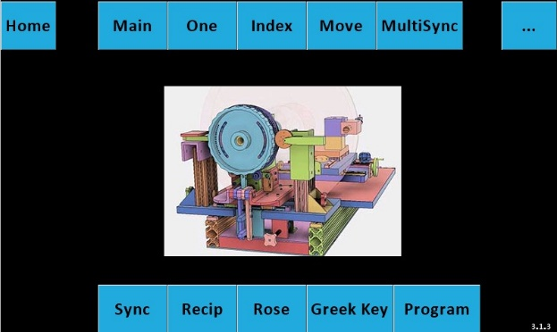

Purpose: Initialize program
Buttons explanation: Touching one of the top or bottom row buttons will take you to that screen.

Main Screen
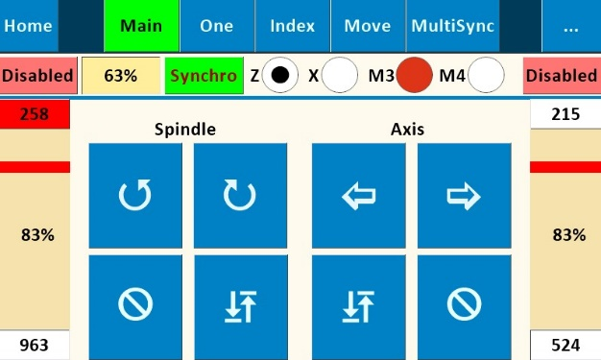

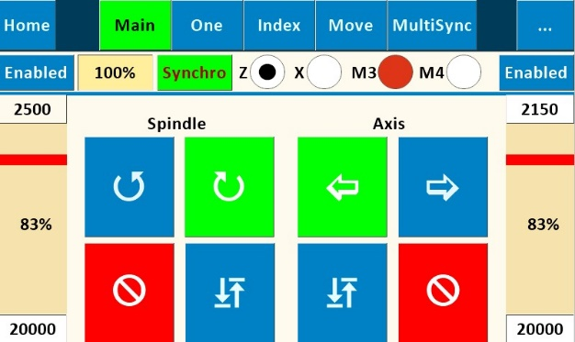

Purpose: Allows direct control of spindle speed and direction and auxiliary axis speed and direction independent of one another. Typically used for continuous spindle and/or continuous Axis motion (turning or facing cuts, continuous rose engine patterns on cylindrical or face surfaces., etc.).
Buttons explanation:
- “” (Counterclockwise) and “” (Clockwise) rotational arrows indicate direction of the Spindle. “”(In) and “”(Out) indicates direction of the selected axis. Rotation/movement continues until “” (Stop) is pushed.
- Right and left speed bars (for Spindle and Axes, respectively, are shown as a percentage of maximum speeds set for “Main” and “Z, X, M3 or M4 Axes”. Max speed and acceleration entry fields are shown at the top and bottom of each speed bar. They are in stepper steps per second.
- “ “(Return): Returns the spindle or the selected axis to the start point of the previous operation.
- Synchro: Runs the spindle and M3 synchronously at the specified percentages. Negative number runs the spindle and M3 in opposite directions.

Number Pad Screen
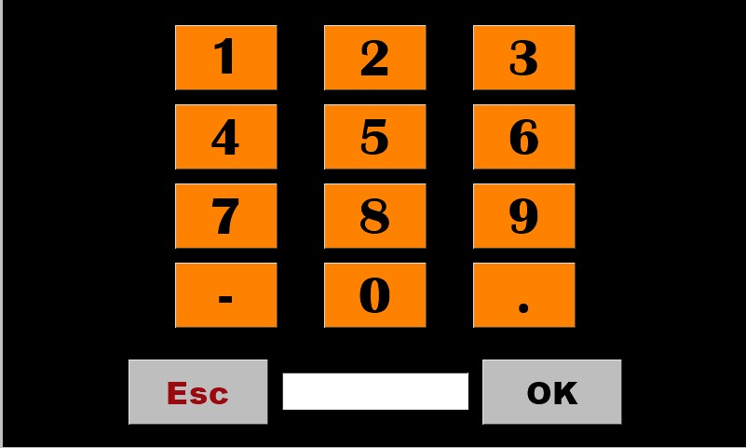
Purpose: This screen appears whenever any numerical value on any screen is tapped. Revise the number in the box by tapping the box multiple times to “backspace” over each digit or decimal point, and then re-enter the new value using the number pad buttons. Pressing “OK” saves the number back to the value box on the previous screen and returns user to that screen.

Synchronization Screen
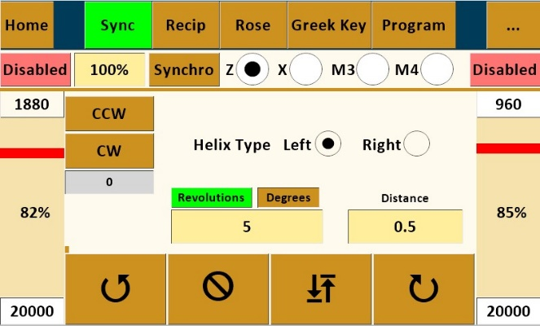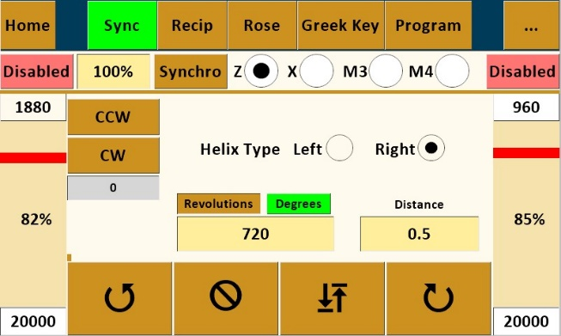
Purpose: Synchronizes the Spindle and Auxiliary Axis to produce helical patterns or threads on cylindrical surface of workpiece or to produce spirals on a face surface.

Buttons explanation:
- “Left” and “Right” determine whether helix runs clockwise or counterclockwise on the piece.
- “CW” (Clockwise) and “CCW” (Counterclockwise) index the spindle for the next cut path – either clockwise or counterclockwise per user design. Amount the spindle will index uses the value in “Size” set in the box on the Index #1 Screen (this value could be either in divisions of a circle or degrees depending upon which option is toggled on Index #1 Screen).
- “Revolutions or Degrees” variable value determines how far around the piece the helix will travel based on the spindle rotating. The value of 4 illustrated will rotate spindle 4 revolutions while the value 720 will rotate the spindle 720 degrees.
- “Distance” variable value determines the cut length (amount of Z axis movement) and is dependent upon value entered in Setup Screen for “Distance/360”.
- Right and left speed bars (for Spindle and Axis, respectively, are shown as a percentage of maximum speeds set on the Configuration Screen for “Sync” and “Z Axis”, respectively. Note that slowest value on speed bars will “control” the other value.
- “”(In) and “”(Out) determine whether cut is made toward or away from headstock. Pattern will run the pre-determined “Distance” and then stop and wait for return direction instruction. User chooses whether to cut in both directions or retract cutter and return to start without cutting.
- “ “(Return): Returns both the spindle and the axis to the start point of the previous operation.
- See appendix for procedure for using the Synchronization Screen for thread cutting.

Reciprocation – Axial
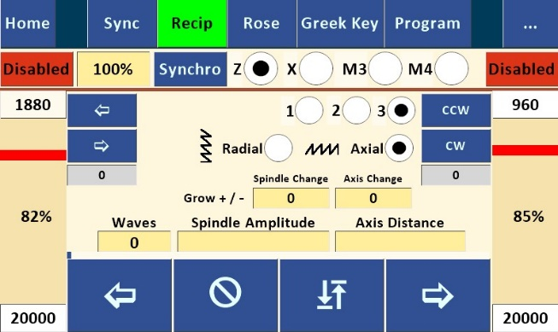

Purpose: Synchronizes Spindle and Auxiliary Axis to produce a reciprocating pattern along the longitudinal cylindrical surface of workpiece: It works by reversing spindle direction alternately while Z or X axis continues in the same direction.
Buttons explanation

- “1” Pattern is an equal angle on the up and down legs.
- “2” Pattern is a square wave.
- “3” Pattern is a like a sawtooth. The up leg is angled, the down leg is straight down.
- “CW” (Clockwise) and “CCW” (Counterclockwise) index the spindle for the next reciprocating cut path – either clockwise or counterclockwise per user design or desire. Amount the spindle will index uses the value set in the “Size” box on the Index #1 Screen (this value could be either in divisions of a circle or degrees depending upon which option is toggled on Index #1 Screen).
- “Wave Count” variable sets number of individual waves /\ to be cut along the cylinder.
- “Spindle Amplitude” variable sets “height” of each wave in degrees of rotation.
- Retrograde changes the length of each leg by the specified amount either plus or minus.
- No Last Leg removes the final leg of a Square wave (pattern 2).
- “Axis Distance” variable determines the cut length for entire pattern (amount of Z, X, M3, or M4 axis movement) and is dependent upon value entered in Setup Screen for “Distance/360”.
- “”(In) and “”(Out) determine whether cut is made toward or away from headstock. Note that “”(In) starts with a downward move and “”(Out) starts with an upward move (test your individual machine and apparatus to verify – your results may vary). Pattern will run the pre-determined “Axis Distance” and then stop and wait for return direction instruction. User chooses whether to cut in both directions or retract cutter and return to start without cutting.
- “ “(Return): Returns both the spindle and the axis to the start point of the previous operation.

Reciprocation –Radial
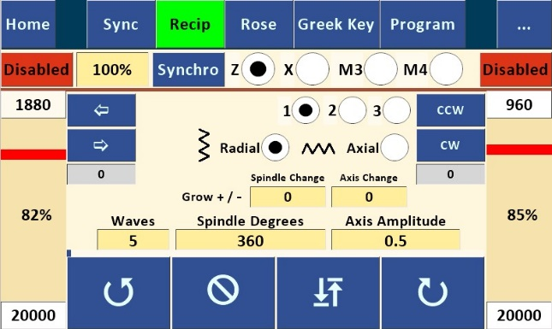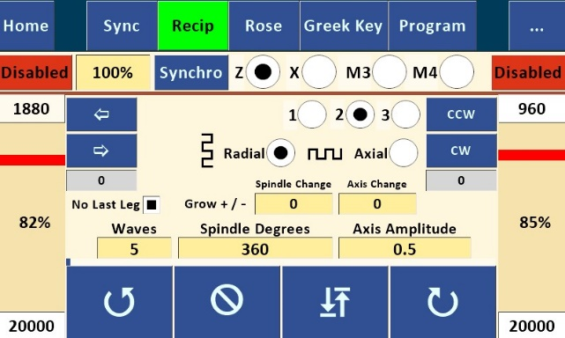

Purpose: Synchronizes Spindle and Auxiliary Axis to produce a sharp-pointed reciprocating pattern along the circumferential surface of a cylindrical workpiece: It works by alternately reversing Z or X axis direction while spindle continues rotating in the same direction.

Buttons explanation
- To navigate to this screen, start with “Recip” and toggle from Axial to Radial.
- “1” Pattern is an equal angle on the up and down legs.
- “2” Pattern is a square wave.
- “3” Pattern is a like a sawtooth. The up leg is angled, the down leg is straight down.
- Small “”(In) and “”(Out) move the Z or X axis to the next pattern starting position. Z or X axis movement will be the value of “Distance” set on the Move Screen for that axis.
- “Return” button rotates the spindle to the pattern start point.
- “Acceleration” and “Speed” values for this screen are set here for both Spindle, Z, and X axes. See notes on value limitations under Configuration Screen explanation. Because of synchronization of the spindle and Z or X axis speeds, one of the maximum speeds will control the other.
- “Wave Count” variable sets number of individual waves ( > ) to be cut along the cylinder.
- “Spindle Degrees” variable sets the circumferential distance around the cylinder for the total pattern. Entering 360 would wrap the pattern all the way around the cylinder; entering 90 would condense the whole pattern around just 90 degrees of the cylinder.
- “Axis Amplitude” variable sets “height” (distance along Z, X, M3 or M4 axis) of each wave and is dependent upon value entered in Setup Screen for “Distance/360”.
- Large “”(In) and “”(Out) buttons determine the direction of cut around the spindle. Pattern will run the pre-determined “Spindle Degrees” then stop and wait for return direction instruction. User chooses whether to cut in both directions (either on the same cut path or on subsequent path) or retract cutter and return to the origin point without cutting.
- “ “(Return): Returns both the spindle and the axis to the start point of the previous operation.

One Screen (Single Stepper Screen)

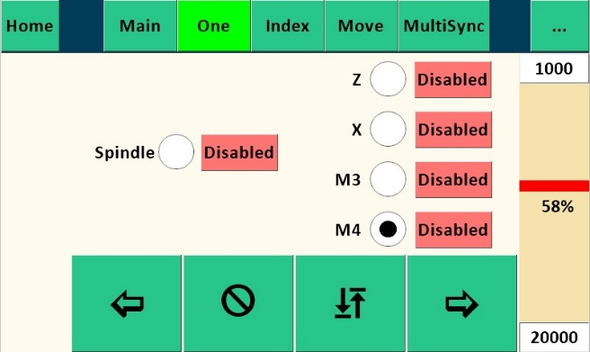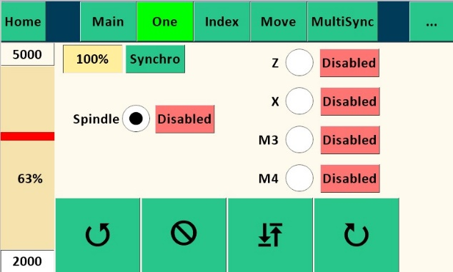

Purpose: Allows control of either the spindle or a single axis speed and direction. Useful for secondary spindle operation such as higher or lower speed functions than the Main Screen.
Buttons explanation
- “Enabled” shows status (either “Enabled” or “Disabled”) of either Spindle stepper motor or an Axis stepper motor as selected. If enabled, the motor is in locked status; if disabled, the selected motor can be repositioned. Default is “Disabled”. Primary use for these buttons is to lock the spindle or axis while performing another operation.
- “” (Counterclockwise) and “” (Clockwise) rotational arrows indicate direction of the Spindle .“”(In) and “”(Out) buttons indicate direction of an axis. Movement continues until “Stop” is pushed.
- Speed bar is shown only for the selected axis or spindle.

Index Screen
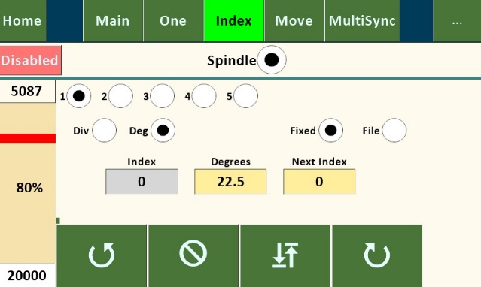
Purpose: Allows indexing spindle for use in index work or other uses.
Buttons explanation

- 1-5: Individual indexes
- “Div” radio button sets the indexing to number of divisions of a full rotation, toggling to “Deg” sets the indexing to number of degrees.
- “Index” box shows current completed index
- “Next Index” shows ID of the next index. It will show lower ID if the CW button was last touched and higher if CCW button was touched
- Speed bar is shown as a percentage of maximum speeds set on the Configuration Screen for “Index”.
- “Divisions” of a circle or “Degrees”, depending upon which is toggled. Note that the value of the selected index (1 through 5) is used by the “CW” and “CCW” indexing movements on the Synchronization Screen and the Reciprocation – Axis Screen in either “Divisions” or “Degrees”, depending upon which is toggled.
- M3 and M4 will only be shown if they are set to Radial on their respective configuration screens.

Index Screen with file dropdown open
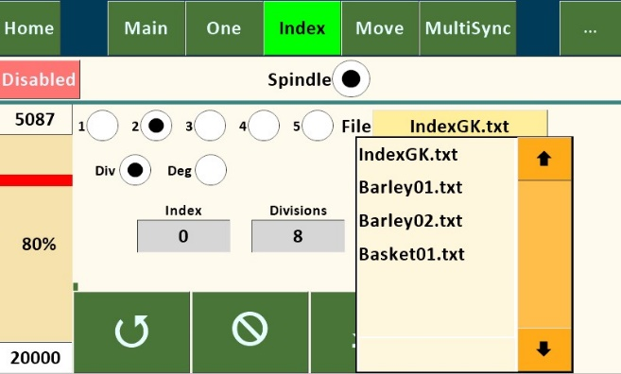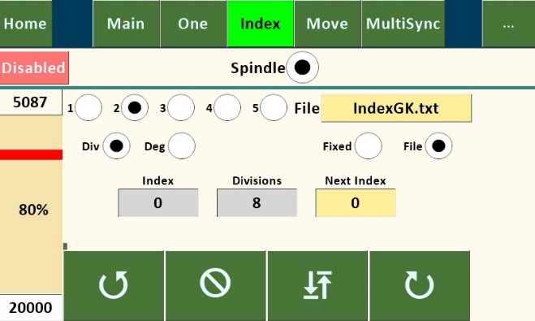

Purpose: Allows variable index sizes to be retrieved sequentially from a file stored on a microSD card. This feature could be used to place evenly spaced features (such as barleycorns) around the circumference of an ellipse (i.e. equal division of the ellipse), with the angular movement in degrees precalculated using a CAD program.

Selecting the filename text box will open a dropdown list of files located on the microSD card. Use the Up and Down arrows to traverse the file list. While the dropdown list is active, all other controls on the page are disabled. The dropdown list can be closed either by selecting a file, or by touching the Filename textbox. Each Index may have its own file.

The file format is ASCII text (numbers, letters, and decimal only) with each number on a new line, saved to the microSD card using a separate computer. Because the SD Card library only supports the 8.3 or Short File
Name convention, the file name must be a maximum 8 characters + a period + three-character extension (thus the 8.3); the name is not case sensitive. It's not necessary to have the extension, but the limit for the name is 8 characters when no extension is used. Multiple files can be loaded onto the microSD card for use on one or more work pieces as desired.

The counterclockwise and clockwise arrows determine direction of spindle movement during indexing. When using the “File” version, each successive index will read successive file numbers off the microSD card (in either “Div” or “Deg” as selected on this screen). When the end of the file is reached, “Size” will be reset to 0. The “Index” value will be increased when indexing clockwise and decreased when indexing counterclockwise. The read position of the file can also be set by editing the “Index” value.
The “Div” and “Deg” radio buttons and the “Enabled” button work the same as on the other Index screens above.

Move Screen
 | 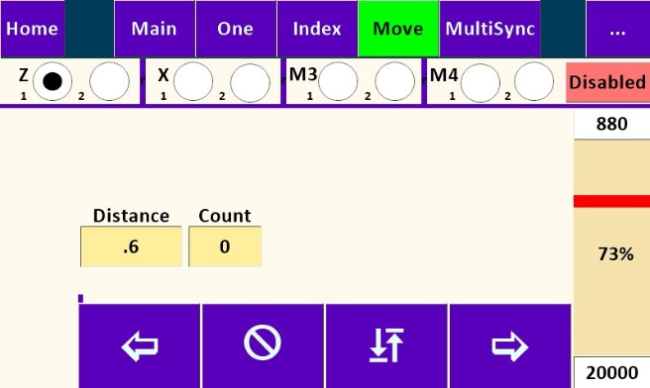 | 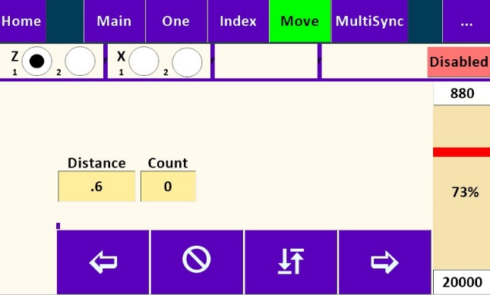

Purpose: Moves the Z or X Axis a specific distance and direction. This could be used to cut a flute or other element along Z Axis of specific length, or used on the end face of a cylinder if set up to drive the X Axis, to move a specific distance to produce rose engine basket weave or other repeating design element on the cylindrical surface of the workpiece, or to plunge in and out of cylindrical surface to do index work if set up for X Axis. Each axis has two separate move settings.
Buttons explanation:
- “Distance” variable sets amount of movement along Z or X Axis and is controlled by Setup Screen Value “Distance/360”.
- “Count” tracks the number of moves.
- “Total” tracks total distance of movement (adding in one direction, subtracting in the other.
- “In” and “Out” indicate direction of the Axis movement. Movement will continue for “Distance” set and then stop and wait for another move instruction, either repeating move or returning to origin.
- Speed bar is shown as a percentage of maximum speed set on the Configuration Screen for “Z or X
Axis”.
- M3 and M4 will only be shown if they are set to Linear on their respective configuration screens.

Home Screen

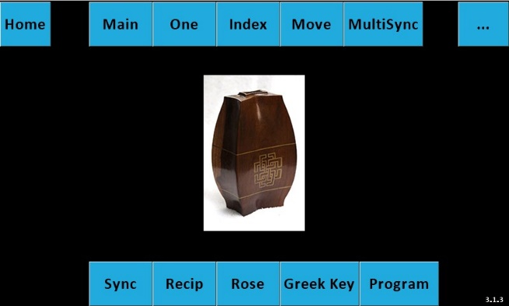

The Home screen contains links to all of the pages.

Rose Screen
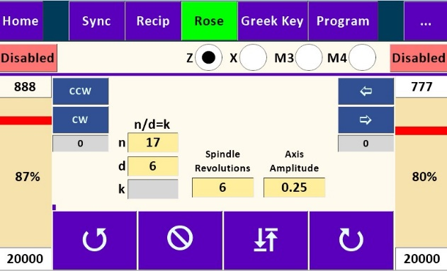

Purpose: Create Rose or single stage geometric chuck patterns, see Wikipedia Rose (mathematics).
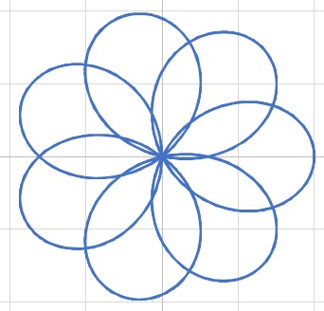
Buttons explanation:
- “n” numerator. Values may be integers or floating point.
- “d” denominator. Values may be integers or floating point.
- “k” ratio of n/d.
- “Amplitude” variable sets “height” (distance along Z or X Axes) of each lobe and is dependent upon value entered in Setup Screen for “Distance/360”.
- “” (Clockwise) and “” (Counterclockwise) rotational arrows indicate direction of the Spindle. Rose pattern continues until “Stop” is pushed.
- “ “(Return): Returns both the spindle and the axis to the start point of the rose pattern.
- Note: M3 or M4 axes only available when they are set to Linear on the M3 or M4 Axis Configuration page.

Grk (Greek Key or Meander) Pattern Screen
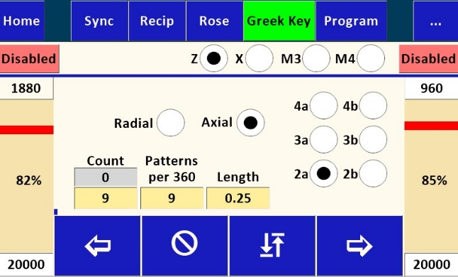

Purpose: Create Greek Key or Meander patterns. The Pattern page has six built-in patterns. Patterns are created by moving either the spindle or one of the axes individually.
Buttons explanation:
- Pattern: Create a Greek Key using one of the built-in patterns.
- File: Create a Greek Key by reading values from a file. See below.
- Radial or Axial: Creates a pattern radially (circumferentially) of axial.
- 4a and 4b: Create a pattern four segments wide. 4a is eight segments tall, 4b is thirteen segments tall.
- 3a and 3b: Create a pattern three segments wide. 3a is four segments tall. 3b is eight segments tall.
- 2a and 2b: Create a pattern two segments wide. 2a is three segments tall. 2b is six segments tall.
- Length: Specifies the length of the shortest Z or X axis segment. Each pattern will have segments which are a multiple of the shortest segment.
- Patterns Per 360: Specifies how many individual patterns will fit in 360 degree rotation of the spindle. This controls the length of the shortest spindle segment.
- Count: Determines the actual number of patterns to create. Setting it less than the Patterns Per 360 value will leave a space at the end of the pattern. Setting it larger will recut the same pattern. This is useful when you want to cut a pattern deeper. Grey box shows the current executing pattern count.
The following shows each pattern. The numbers by each segment indicate the length of that segment. The arrows show the direction the cutter is traveling. When the arrows change color it indicates the next segment’s direction.
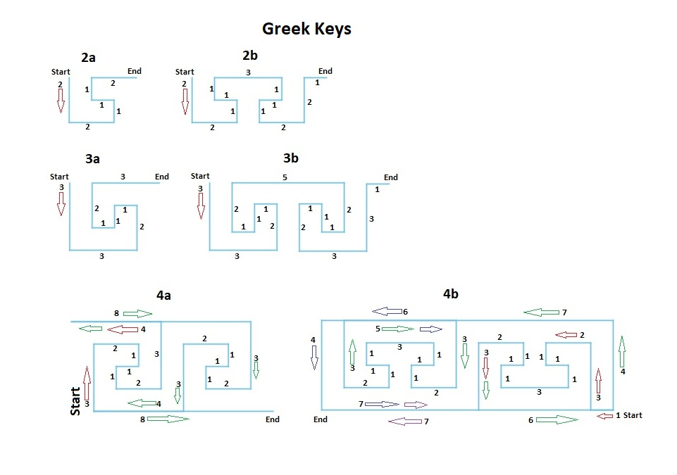

Program from File Screen
 | 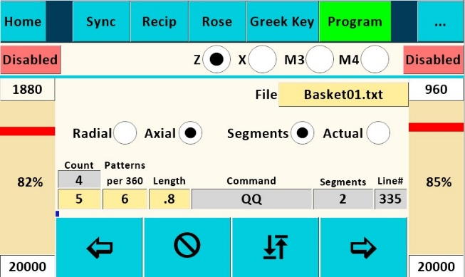 | 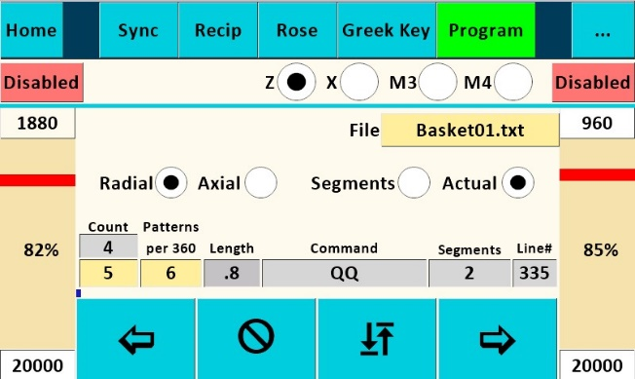

Purpose: Create Greek Key or Meander patterns by reading values from a file.
Buttons explanation:
- Filename must be in 8.3 format: 8 character name, a period, and a 3 character extension. It isn’t necessary to have the full 8.3 characters. Note: Apple computers may automatically add “.txt” to the name.
- Selecting the filename text box will open a dropdown list of files located on the microSD card. Use the Up and Down arrows to traverse the file list. While the dropdown list is active, all other controls on the page are disabled. The dropdown list can be closed either by selecting a file, or by touching the Filename textbox.
- Segments: Values in the file are interpreted as a multiplier of the “Length” for the Z, X, M3 or M4 axes and as a multiplier of the calculated segment size for the spindle. Floating point numbers are valid.
- Actual: Values in the file are used as the length of the move. Floating point numbers are valid.
- Grey boxes: Command, Segments, and Line# show the values for the current line in the file being executed. Count shows the current executing pattern count.

File format:
The file must be plain text (ASCII).
Each line in the file must begin with an axis identifier letter and end with the length of the move, except for the Comment and End lines.

Identifiers:
- ; Comment: Begins with a semi-colon, “;”, and may have up to 25 characters. There is no limit on the number of comment lines in a file. Each comment line must have a least one additional character.
- E End: Begins with a capital “E”. All files must have this as the last line in the file.
- WS(Plus count of vertical segments in the pattern). Required for all radial patterns.
- WA(Plus count of horizontal segments in the pattern). Required for all axial patterns.
- WB(Plus count of M3 radial segments in the pattern). Valid when M3 is Radial and rotating the workpiece. Do not use when M3 is Radial or Linear and driving a sliderest.
- WD(Plus count of M4 radial segments in the pattern). Valid when M4 is Radial and rotating the workpiece. Do not use when M4 is Radial or Linear and driving a sliderest.
The following commands can be interpreted as having a multiplier or as the actual size of the move.
- A(Plus multiplier or actual length) Negative number moves axis towards the spindle, positive moves away.
- S(Plus multiplier or actual length) Negative number moves spindle CCW, positive moves CW.
- H(Plus multiplier or actual length)V(Plus multiplier or actual length) Specifies a coordinated diagonal move with the spindle and the active axis. H is a horizontal move with the axis and V is vertical move with the spindle. Each move is a leg of a right triangle.
- P(Plus multiplier) Pause in seconds.
- O(Plus multiplier or actual length) Moves the cutter away from the workpiece.
- I(Plus multiplier or actual length) Moves the cutter into the workpiece.
- X(Plus multiplier or actual length) Moves X axis. Negative numbers reverse direction.
- Z(Plus multiplier or actual length) Moves Z axis. Negative numbers reverse direction.
- B(Plus multiplier or actual length) Moves M3 axis. Negative numbers reverse direction.
- C(Plus multiplier or actual length) Moves Spindle. Negative numbers reverse direction. (C is a rotary axis parallel to the spindle and to Z.)
- D(Plus multiplier or actual length) Moves M4 axis. Negative numbers reverse direction.
- T(Primary axis Id: BDSXZ B=M3,D=M4,S=Spindle,X, or Z) (Plus multiplier or actual length) Moves) (Secondary axis Id: BDSXZ B=M3,D=M4,S=Spindle,X, or Z) (Plus multiplier or actual length) Moves) This works similar to the HV command except you can specify which two axes(motors) you want to move. This allows Cartesian movements when the M3 or M4 are set to Linear, and Polar movements when they are set to Radial.

M3 Parameters
- JR – M3radius
M4 Parameters
- LR – M4Radius
Page commands. These use settings on the individual pages
Q commands are deprecated.
- QM(Plus multiplier) Moves an axis using settings on the MOV page. -1 multiplier moves towards the headstock, 1 moves away from the headstock.
- QI(Plus multiplier) Index the spindle using settings on the IND page. -1 multiplier moves CCW, 1 moves CW.
- QR(Plus multiplier) Reciprocate using settings on the REC page. -1 multiplier moves towards the headstock, 1 moves away from the headstock.
- QS(Plus multiplier) Synchronize spindle and axis using settings on the SYNC page. -1 multiplier moves towards the headstock, 1 moves away from the headstock.
Page settings. These set parameters on the pages.
Sync page:
- GG(Plus multiplier) Synchronize spindle and axis using settings on the SYNC page. -1 multiplier moves towards the headstock, 1 moves away from the headstock.
- GH - Sync Helix Type 0=left 1=right
- GD - Sync Distance (floating point)
- GR - Sync Revolutions (floating point)
Recip page:
- VV(Plus multiplier) Reciprocate using settings on the RECIP page. -1 multiplier moves towards the headstock, 1 moves away from the headstock.
- VT - Recip Radial =0 Axial=1
- VK - Recip Style
- VW- Recip Waves (Integer)
- VS - RecipSpindle (floating point)
- VA - Recip Axis (floating point)
Move page:
- FF(Plus multiplier) Moves an axis using settings on the MOVE page. -1 multiplier moves towards the headstock, 1 moves away from the headstock.
- FD - Move Distance (floating point)
Index page:
- NN(Plus multiplier) Index the spindle using settings on the INDEX page. -1 multiplier moves CCW, 1 moves CW.
- NT - Index Divisions=1 Degrees=2
- NI - Index Division or degrees size (floating point)
- ND- Index Division or Degrees size (floating point)
- NJ - Index ID (Integer from 1 to 5)
MultiSync page:
- QQ – Executes MultiSync page
- QA - X target (floating point)
- QB - X waves (integer)
- QC - X direction (2 = right arrow, 3 = left arrow)
- QD - X checked (1 = selected; 0 = unselected)
- QE - Z target (floating point)
- QF - Z waves (integer)
- QG - Z direction (2 = right arrow, 3 = left arrow)
- QH - Z checked
- QI - M3 target (floating point)
- QJ - M3 waves (integer)
- QK - M3 direction (2 = right arrow or CW, 3 = left arrow or CCW)
- QL - M3 checked (1 = selected; 0 = unselected)
- QM - M4 target (floating point)
- QN - M4 waves (integer)
- QO - M4 direction (2 = right arrow or CW, 3 = left arrow or CCW)
- QP - M4 checked (1 = selected; 0 = unselected)
- QS - Spindle target (floating point)
- QT - Spindle waves (integer)
- QU - Spindle direction (2 = CW, 3 = CCW)
- QV - Spindle checked (1 = selected; 0 = unselected)
Rose page:
- RR(Plus multiplier) Execute Rose page. -1 multiplier moves towards the headstock, 1 moves away from the headstock.
- RN - Set n (floating point)
- RD - Set d (floating point)
- RS - Set spindle revolutions (floating point)
- RA - Set axis distance (floating point)

Enable/Disable Steppers
- KS(Plus multiplier) Enable or Disable Spindle. Disable = 0, Enable =1.
- KX(Plus multiplier) Enable or Disable X Axis. Disable = 0, Enable =1.
- KZ(Plus multiplier) Enable or Disable Z Axis. Disable = 0, Enable =1.
- KB(Plus multiplier) Enable or Disable M3 Axis. Disable = 0, Enable =1.
- KD(Plus multiplier) Enable or Disable M4 Axis. Disable = 0, Enable =1.

- KA(Plus multiplier) Enable or Disable current Program page axis. Disable = 0, Enable =1.
- Note: Steppers are automatically enabled when executing a command, so it is not necessary to enable one after disabling it.

Example file:

;Pattern 2a
WS3
WA2
A2
S-2
A-1
S1
A-1
S-2
E

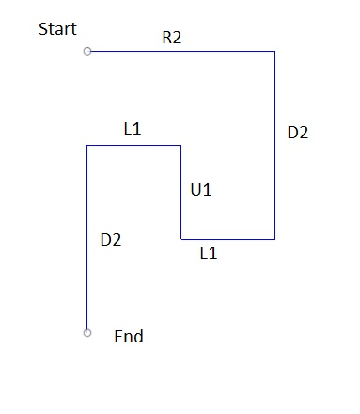

MultiSync Screen
 | 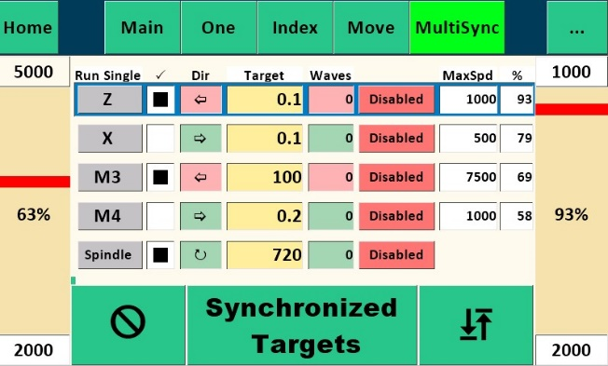 | 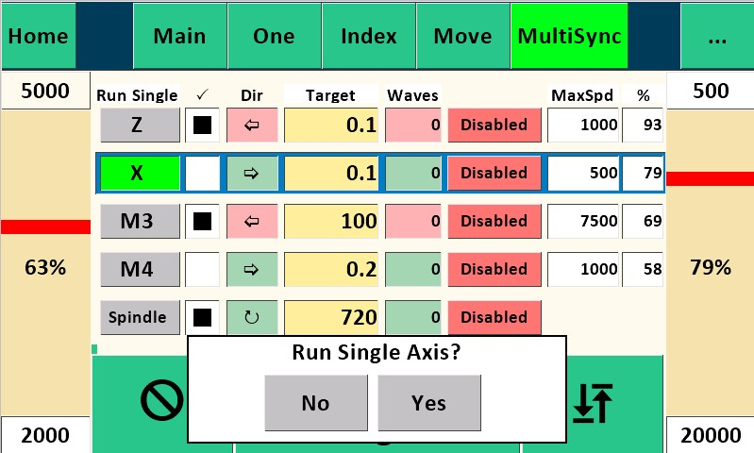

Purpose: Run multiple motors synchronously or individual motors continuously.
Buttons explanation:
- Grey buttons run the selected axis in continuous mode. Motor will run until Stop is pressed.
- Check column: Selected axes are run synchronously until each reach the Target.
- Dir column: Indicates direction motor will run.
- Target column: Target distance, may be either lineal or radial depending on the settings on M3 or M4 pages. Radial targets are in degrees. Lineal in distance.
- Enable/Disable column: Enables or disables the stepper motor.

Preferences Screens
Purpose: The factors on these screens control how speeds and distances are determined. The left columns show settings on the Nextion. Touching one of the text boxes allows you to edit that value. The right columns show settings stored on the Teensy. These are read only and should match the left column settings.

Spindle
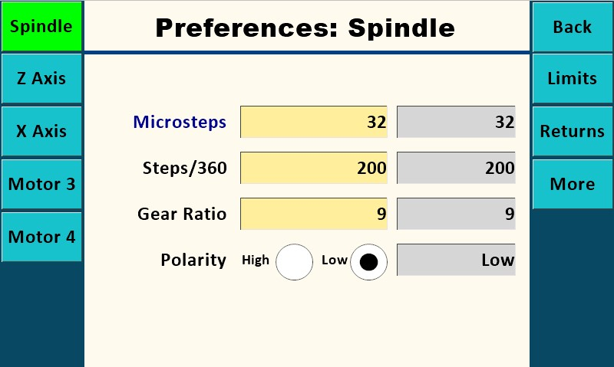

Buttons explanation:
- The software is currently set up for 32 Microsteps, 200 Steps/360, and 9 Gear Ratio for the spindle. This assumes a stepper motor with 200 steps per revolution and is the “standard” configuration for the
MDF Rose Engine with a 12 tooth spindle motor drive pulley and 108 tooth driven pulley yielding a Gear Ratio of 9. Once set, the values for the Spindle will remain the same unless changes are made to spindle drive setup.

Z Axis
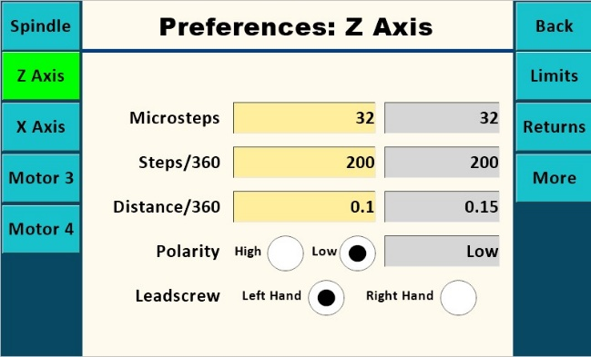
- The Z axis screen shows 32 Microsteps, and that you are using a stepper motor with 200 Steps/360. This is intended to show microstep values must use valid values for the stepper driver, usually 1, 2, 4, 16, 32, 64, and 128. These settings must match the jumper settings on the PCB.
- The “Distance/360” is the distance the Z axis carriage moves in one revolution of its stepper motor. It is a value arrived at empirically by measuring the movement of the Z Axis using a dial indicator or other appropriate device while the stepper motor revolves a set number of turns. This can be accomplished by entering a value in “Distance/360” such as 1, then using the Move Screen to move a “Distance” of 20 while measuring. This should turn the motor through 20 full revolutions. Divide the distance traveled by 20 and enter calculated value into “Distance/360”. If the total distance moved in 20 revolutions is insignificant, use a larger “Distance” number like 50 (or even 100). Note that best practice is to remove backlash from the Axis mechanism prior to the measurement run by moving the axis in the same direction. It may be possible to get a starting point for Distance/360 by calculation calculating the stepper pulley to driven pulley ratio, and/or the thread pitch.
Finally, it’s important to note that if you use different pieces of apparatus (such as a cross-slide, a spherical or a curvilinear apparatus) with the Z Axis, each will likely have a different value for Distance/360, so keep track of these separately for each piece of apparatus (See Load Ini section).
- The Enable “High” and “Low” radio buttons for both Spindle and Z Axis are set to “Low” by default, which is the correct setting when using the DRV8825 Stepper Drivers. The “High” setting is for use for some external stepper drivers.
- “Hand” should be set to the thread direction of the axis leadscrew. If using a Hardinge compound sliderest with a left-hand thread, for example, set “Hand” to “L”. If using an apparatus with a righthand threaded rod, set “Hand” to “R”. Test to verify.
- “Back” button returns to the previous screen.
- “Limits” button activates the Limits Screen.
- “Returns” button activates the Returns Screen.
- “Refresh”: Retrieves settings stored on the Teensy. These settings should match the left columns which are stored on the Nextion.

X Axis
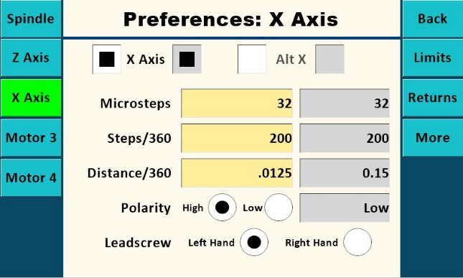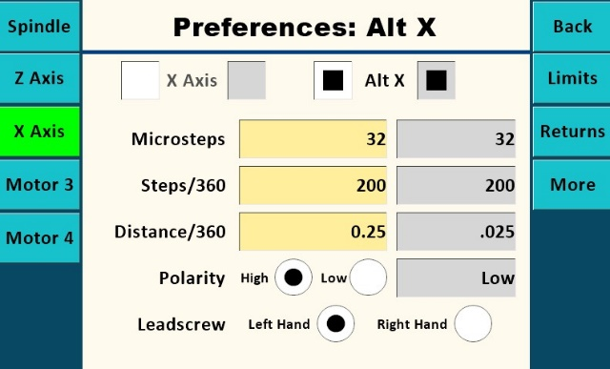

- The X axis can use two different steppers. Alternate X will usually be used to adjust a curvilinear arm while the main X axis is floating.

M3 Axis
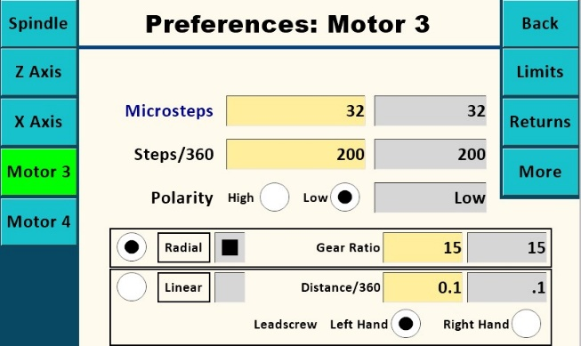
- The M3 Axis can be configured as either a radial axis, like a spherical apparatus or a spindle, or as a linear axis. When configured as a radial axis for a spherical device it uses a calculated distance along the circumference based on the radius length between the spherical device pivot point and the cutter. The ‘M3 Radius’ text box will appear on a page when the M3 axis is active and the M3 axis is set to Radial.
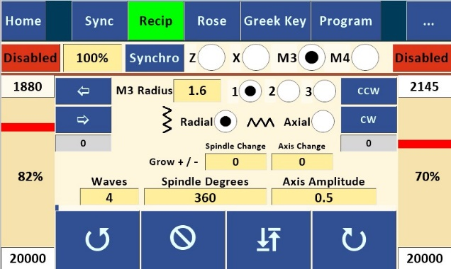

M4 Axis
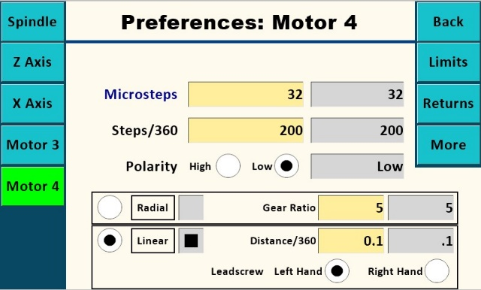
- The M4 Axis can be configured as either a radial axis, like a spherical apparatus or a spindle, or as a linear axis. When configured as a radial axis for a spherical device it uses a calculated distance along the circumference based on the radius length between the spherical device pivot point and the cutter. The ‘M4 Radius’ text box will appear on a page when the M4 axis is active and the M4 axis is set to Radial.

Limits screen
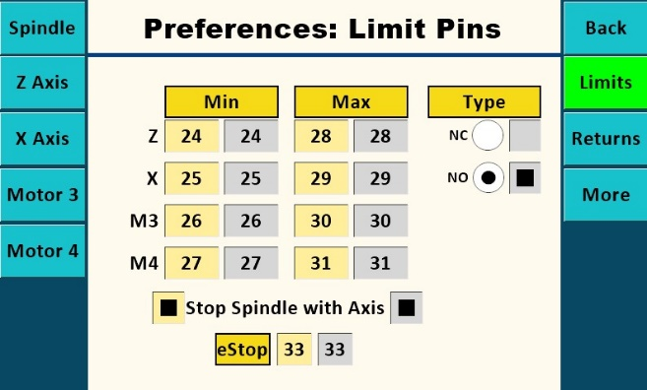

Purpose: Set pin numbers for limit switches.
Limit switches and Estop switch(s) can be wired either normally closed or normally open. Normally closed is recommended. Multiple switches may be wired together serially, not parallel.
When a limit switch is triggered, the action button for that direction limit switch will turn red. No further action can be taken until the “” (Stop) button is touched. Once that is done, the opposite direction action button can be touched while the limit switch is still closed.
Limit Max triggered:
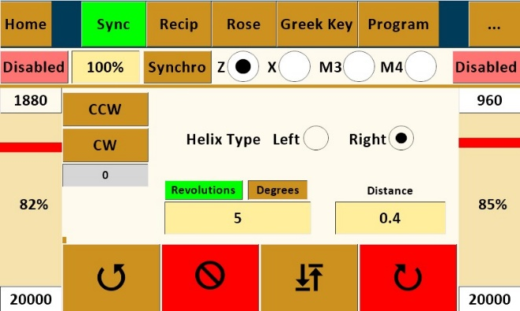
Limit Min triggered:
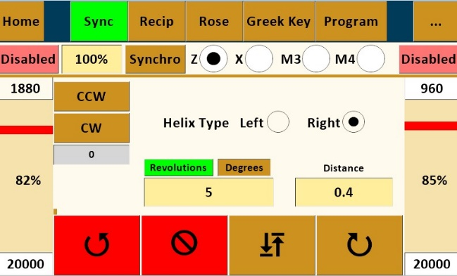
When EStop switch is triggered, the action buttons will turn red. No further action can be taken until one of the “” (Stop) buttons is touched and the EStop switch is not closed.
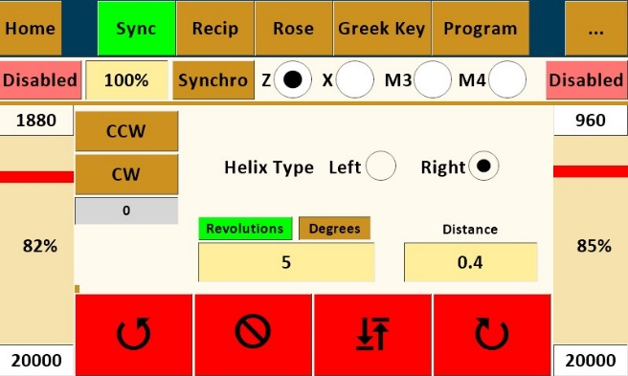

Returns screen
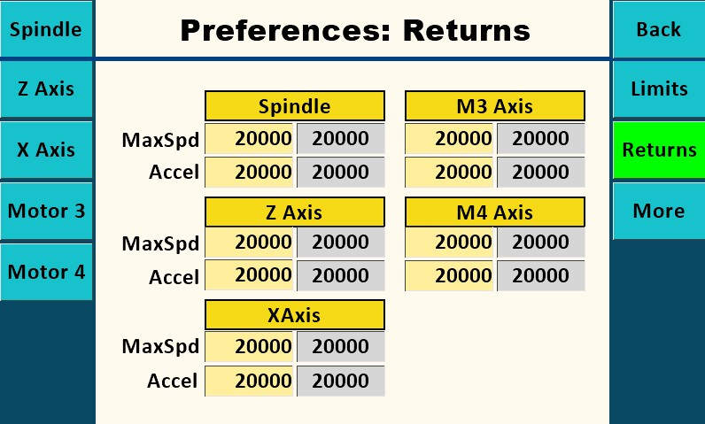

Purpose: Set speed and acceleration for return actions.
More screen
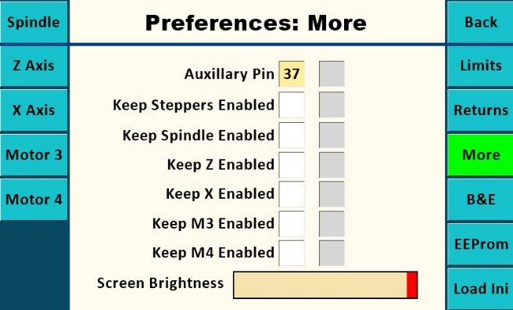

Screen Brightness slider will change the brightness of the screen.
The ‘Show BE’ button will open the BE page.
‘EEPROM’ button shows the values stored in EEPROM on both the Nextion and Teensy. It is used to verify the settings match. Mismatches can occur when updating the software.
The ‘Load Ini’ button will open the Load Ini page.

Load Ini screen
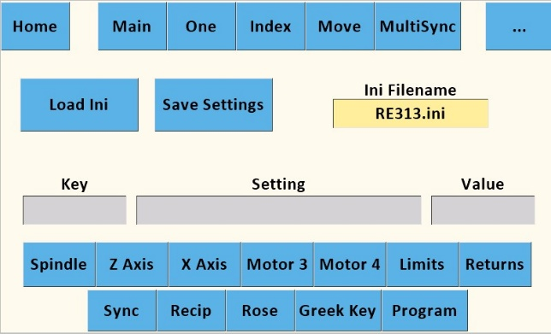
Touching the Load Ini button will download settings from the specified .ini file. Settings are shown in the grey boxes as they are updated. Custom settings may be stored in multiple .ini files.
The other buttons will change the display to the specified page. .

EEPROM screen
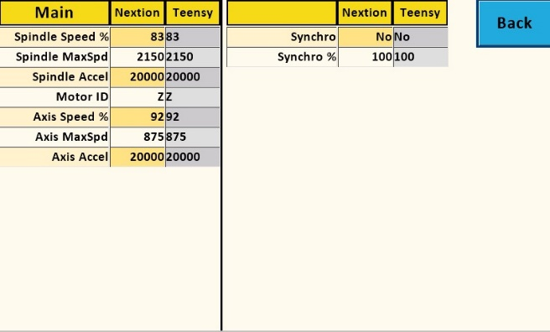
Nextion settings are shown in yellow, Teensy in grey.

will load motor settings from an ini file. Restarting the program may be necessary for the settings to be active. While Load Ini is running, the Key, Setting, and Value fields will show the current values being updated.

B&E screen
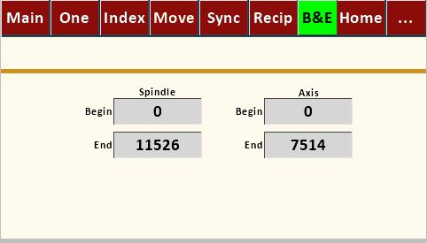
Currently under development. Only the Begin and End text boxes are active. They show the distance or degrees an axis or the spindle has moved from the start of the last operation on another screen. This can be used to verify the specified movement matches the actual movement.

Appendix
General Notes:
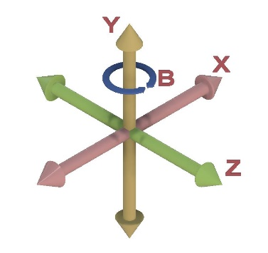
- When first setting up or when updating Teensy or Nextion software, go to each screen in turn and refresh all settings by entering new or current values in the text boxes and pressing “OK”, cycling the radio buttons, and moving the speed sliders.
- X, Z, and B axes for the lathe in descriptions above use the standard shown here:

Exercises
I. Thread Cutting for Boxes with the Synchronization Screen:
Note: refer to instructions in other resources (such as “Turning Threaded Boxes” by John Swanson, Schiffer Publishing, 1999) for box threading tips and techniques.

Example 1: Single-start thread of 16 threads per inch (1/16” pitch).
- Set “Revolutions” to number of threads to be cut around the cylinder. Suggest using “4” as a starting point.
- Set “Distance” to .25 (four threads at 1/16” = ¼”).
- With a 60-degree double angle cutter running in a drilling frame set parallel to the lathe’s spindle and driven by the overhead, test and adjust Spindle and Axis speed bars as necessary to get a usable combination of feed and speed (not so fast as to bog down cutter, not so slow as to burn the wood). If necessary, adjust “MaxSpd” setting on Configuration Screen to get usable combination.
- Test “Left” and “Right” radio buttons to determine which type of thread will be cut (left hand or right hand).
- Choose whether to cut “In” or “Out” based on what makes sense for your piece.
- Cut thread. Typical good practice uses roughing and final cuts for each thread. If wood tends to fuzz up or chip out, it’s common practice to flow some CA glue into the rough threads and let it cure prior to the final cut.
Example 2: Four-start thread of 16 threads per inch (1/16” pitch, ¼” lead)
- Set “Revolutions” to number of threads (of each start) to be cut around the cylinder. Suggest using “1” as a starting point.
- Set “Distance” to .25 (1/4” lead). This will cut one continuous thread traveling ¼” as it goes once around cylinder.
- Got to Index #1 Screen. Select “Div” toggle and set value in “Size” box to “4”. Note: would also work to select “Deg” toggle and set value in “Size” box to “90”.
- Follow steps 3, 4, 5 & 6 in Example 1 above.
- Return to starting point with cutter retracted from work using “In” or “Out” as appropriate.
- Index spindle using either CW or CCW based on personal preference to get to starting point of next thread start. Re-engage cutter and repeat cutting process(es) in step 6 in Example 1 for Start #2. Retract cutter and return to start point of Start #2.
- Repeat indexing and cutting procedures for Starts #3 and #4.

